**INSTALLATION MANUAL**

Table of Contents

1. Install WampServer 3

2. Import Database using WampServer 2.5 3

3. Install JDK 6

4. Install U.are.U Driver 7

5. Install Server 8

6. Install Monitoring System 8

7. Install Lobby System 9

8. Install Backup and Recovery 9

# 1. Install WampServer

*1.1.* Install WampServer 32bit/64bit Version 2.5 provided (..\res\<filename nung wamp>) to the root directory of your drive C:

# 2. Import Database using WampServer 2.5

*2.1*. Import Database:

*2.1.1.* Go to your browser and then type into the address bar the following : <http://localhost/phpmyadmin/index.php>

*2.1.2.* Then press enter.

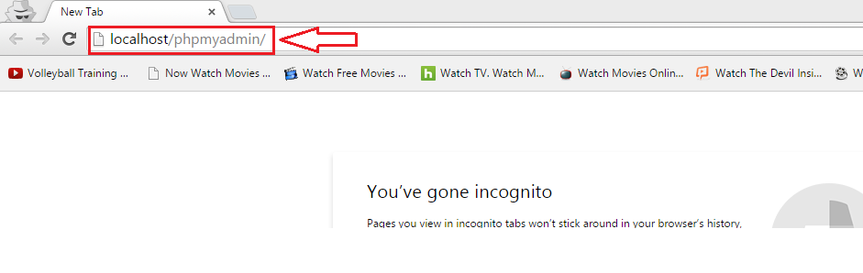

*2.1.3.* Press *Import.* 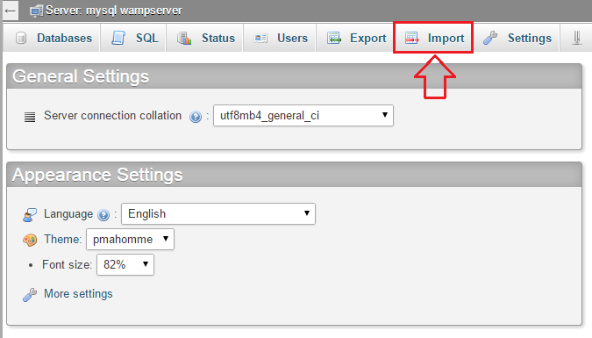

*2.1.4.* Press *Choose File.*

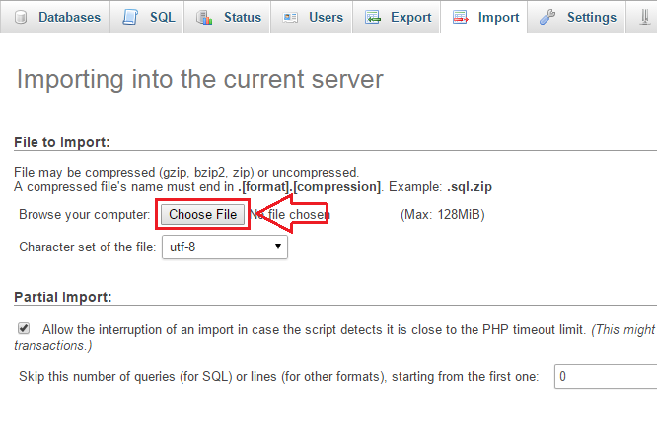

*2.1.5.* Choose the sql file (initialized DB.sql or populated DB.sql) 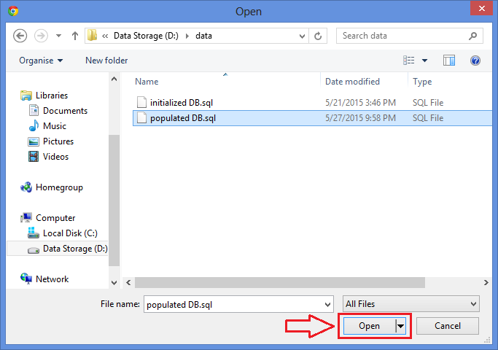 provided: ..\data\initialized DB.sql or ..\data\populated DB.sql

*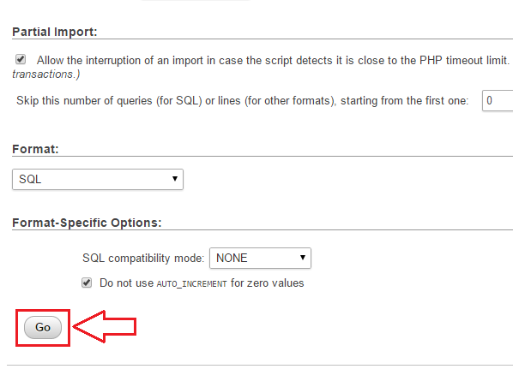2.1.6.* Scroll down and Press *Go.*

*2.1.7.* Wait until it is finished. Then a message will prompt:

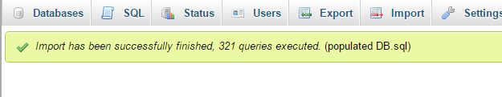

# 3. Install JDK

*3.1.* Install the Java 8 SDK 64 bit provided

*.*.\res\<filename nung java 8>

*3.1.1.* Add JAVA_HOME in System Variables

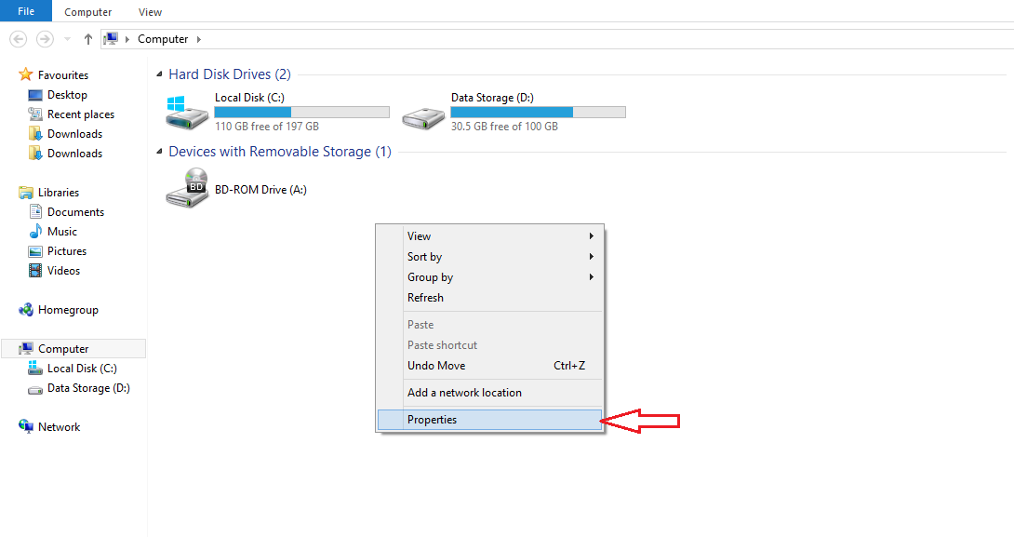 *3.1.1.1.* Go to Environment Variables: Computer > Properties > Advanced System Setting > Environment Variables

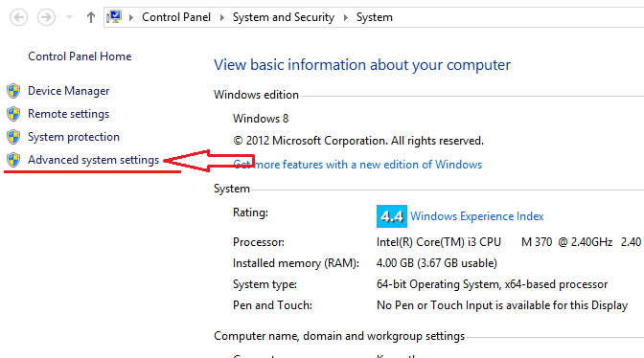

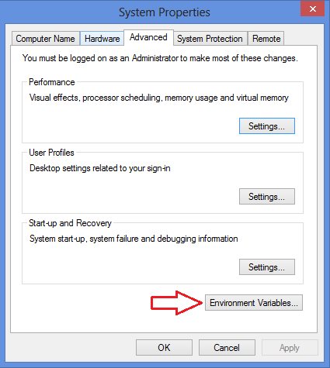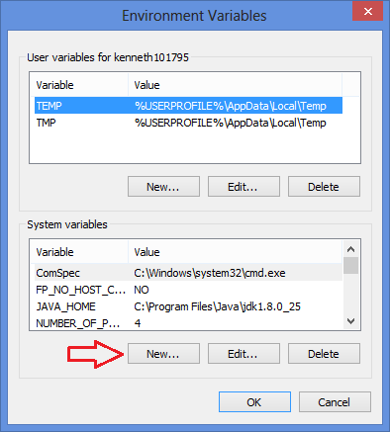

*3.1.1.2.* Then add JAVA_HOME with the path of the existing JDK

(eg. C:\Program Files\Java\jdk1.8.0_25)

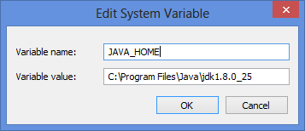

# 

# 4. Install U.are.U Driver

*4.1.* Install the Digital Persona U.ARE.U driver (SETUP.exe) provided

..\res\UareU\SETUP.exe

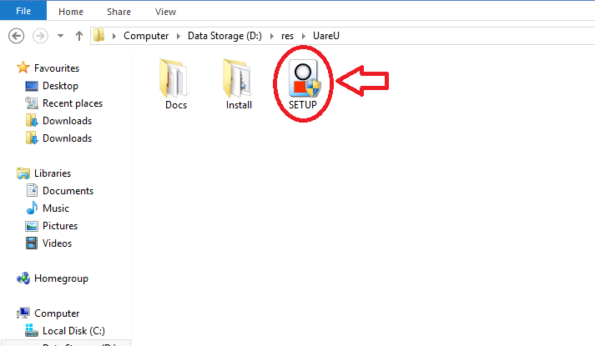

# 

# 5. Install Server

*5.1.* Install the server system (181NPRServerSetup.exe) provided

..\res\181NPRServerSetup.exe

*Note:*

Open command prompt to check ipv4 address by typing “ipconfig”. The ipv4 address will be used to connect the Lobby Unit.

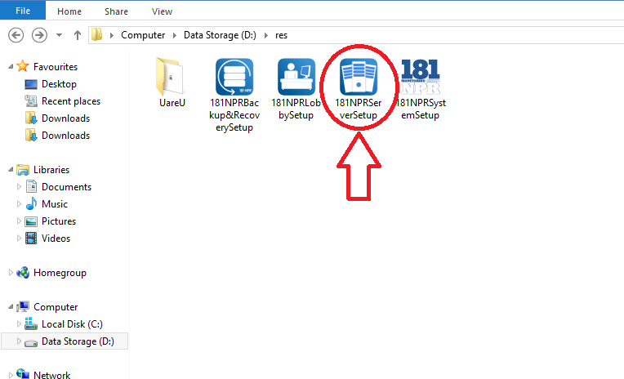

# 

# 6. Install Monitoring System

*6.1.* Install the main system (181NPRSystemSetup.exe) provided

..\res\181NPRSystemSetup.exe

*Note:*

Open command prompt to check ipv4 address by typing “ipconfig”. The ipv4 address will be used to connect the Lobby Unit.

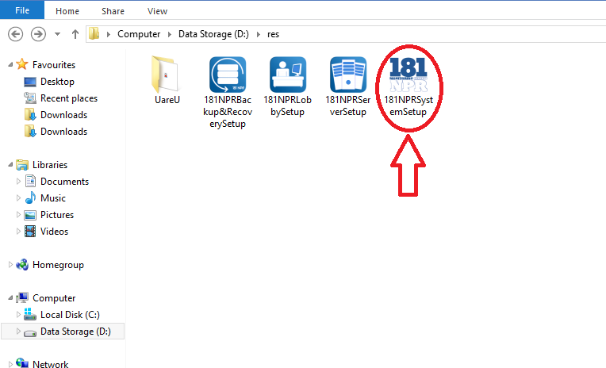

# 7. Install Lobby System

*7.1.* Install the lobby system (181NPRLobbySetup.exe) provided

..\res\181NPRLobbySetup.exe

*Note:*

Make sure the lobby unit, monitoring system and the server are in one (1) network.

If the lobby unit is not connected to the server, type the ipv4 address of the server in the prompt message asking for ipv4 address.

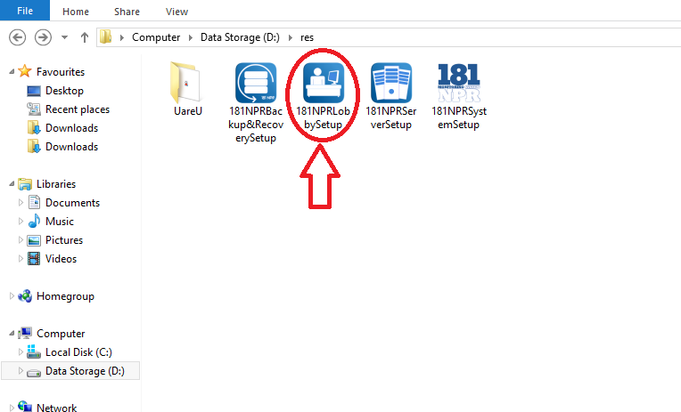

# 8. Install Backup and Recovery

*8.1.* Install the backup and recovery system (181NPRBackup&RecoverySetup.exe) provided

..\res\181NPRBackup&RecoverySetup.exe

